Leoni provides design through to the cable tips for software-supported surgery navigation system

Hybrid cables and sturdy grommets support rapid availability of Brainlab’s Curve™ system

Nuremberg / Friesoythe, 24 April 2014 – Leoni, the leading European provider of cables and cable systems to the automotive sector and other industries, has developed and is making the various microscope cables for the mobile Curve™ system of the Brainlab company – a software-supported navigation system for surgery. Leoni’s solution stands out with durability and robustness together with a reliably high transmission quality. It thereby supports the benefits of the Brainlab Curve™ in terms of mobility, easy handling and rapid availability with a high-quality design – down to the finest detail.
“In Leoni we have found the ideal partner whose experience in the field of cable technology matches our high quality and design expectations in the development of our innovative products. Leoni’s hybrid cables perfectly meet the parameters we set,” said Maurizio Tardino, Purchasing Agent at Brainlab.
Leoni’s assembled cables link the navigation module of Brainlab's Curve™ with the various connectable surgical microscopes and reliably transmit data, images and power. They each comprise a hybrid cable with various connectors, two sturdy extruded grommets, an extruded board and ferrites. As these microscope cables need to be connected quickly and securely, they lie on the operating theatre floor during use and are channelled up along the modules. In addition to high electromagnetic compatibility (EMC) and efficient cleaning in sensitive environments, high tensile strength and resistance to lateral pressure were the key requirements on Leoni’s development.
Leoni’s hybrid cables are non-critical with respect to EMC thanks to specific production methods and a special shielding. Their compact structure and durable PUR jacket ensure great stability together with appropriate flexibility. Not least, these cables are RoHS-compliant and are UL Style 21523 approved for external use. Robust grommets protect the breakout of the cable into its three elements, which makes it easier to clean the cable system and, thanks to an additional loop, the respective cable can be rapidly fixed to modules, beds or frames. This secure fixing also cleverly and simply deflects the pulling forces created by the required carrying capacity.
The Broadcast Technology Institute in Munich tested and confirmed this very good EMC property of Leoni’s power cords in moving use. Leoni subjected the cables, grommets, connectors, ferrites and clips to various mechanical tests to ensure long-term carrying capacity. For instance, a compression test was applied to verify the bulk cable's crush resistance – with an above-average result: the cable withstood the more than 1000 test cycles with a load of 500N without any problem. The strain relief on connectors, grommets, boards, ferrite and clip was also tested. Not until the forces reached nearly 400N did the clip snap in the destructive tests. In some cases the other components withstood tensile forces of up to 900N.
(3,143 characters incl. blanks)
Related illustration material can be downloaded from www.media.leoni.com next to this release
About the Leoni Group

Leoni is a global supplier of wires, optical fibers, cables and cable systems as well as related services for the automotive sector and further industries. Leoni develops and produces technically sophisticated products from single-core automotive cables through to complete wiring systems. Leoni’s product range also comprises wires and strands, standardised cables, special cables and cable system assemblies for various industrial markets. The group of companies, which is listed on the German MDAX, employs about 62,000 people in 33 countries and generated consolidated sales of EUR 3.92 billion in 2013.

Contact person for trade press Contact person for economic press
Birte Wendeln Sven Schmidt
Marketing Business Unit Healthcare Corporate Public & Media Relations
LEONI Special Cables GmbH LEONI AG
Phone +49 (0)4491-291-173 Phone +49 (0)911-2023-467
Fax +49 (0)4491-291-5173 Fax +49 (0)911-2023-231
E-mail birte.wendeln@lsc.leoni.com E-mail presse@leoni.com
Imagery:

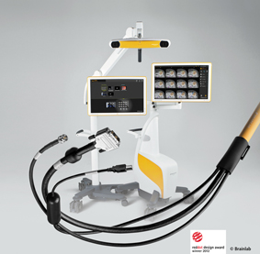  Leoni makes various microscope cables for the mobile Curve™ system of the Brainlab company – a software-supported navigation system for surgery  (provided upon request) | 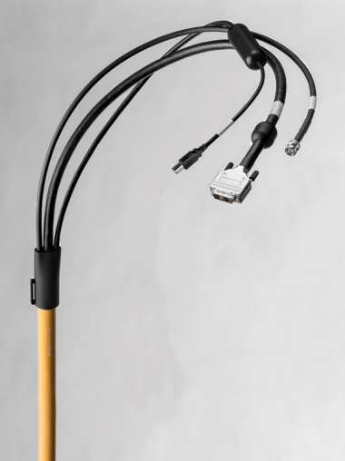  Reliable transmission of data, images and power: Leoni’s hybrid cables are robust, non-critical with respect to EMC and come with a high transmission quality.  (download on the Leoni homepage)

