Leoni provides innovative X-linked compound for all areas of large-scale projects

LEONI X-linked Compound (LE.X.CO) for offshore, railway, industry and marine applications

Nuremberg, 5 November 2015 – Leoni, the leading European provider of optical technologies, cables and cable systems to the automotive sector and other industries, has developed one X-linked jacket material to simplify the cabling of major projects thereby saving up to 75% of the cabling costs.
Major projects include a high complexity of regulations, cable types and installation and handling requirements. To simplify the handling of major projects’ Leoni has developed one X-linked jacket material for almost any cable type, meaning one jacket material fits all requirements – no multiple installation of cables:
LEONI X-Linked COmpound (LE.X.CO).
These advanced and unique X-linked jacket materials are designed to comply with requirements for offshore, railway, industry, marine applications and highly challenging environmental conditions. The cables comply with all requirements of any subsection of large-scaled projects, are available with various and customized cable designs and protection measures (armour, rodent and water protection, assembly options, fire retardant and fire resistant) They reduce planning and installation process preparation and are suitable for a wide range of challenging environmental factors (i.e. Jacket type SHF 2 according to IEC60092-360, MUD-resistant according to NEK606).
Benefits for handling major projects
LE.X.CO significantly reduces total costs of ownership due to simpler cable installation, improved tender comparability and easier handling of project management for the various areas of major projects management. All possible cable designs, including hybrid cables can be realized and there is no limitation of fiber or cable diameter. The assembly and splicing of LE.X.CO cabling is identical to standardized cable types.
Various design capabilities combined with unique material properties
Properties
- Halogen-free (acc. to IEC 60754-1)
- Low degree of gaseous acidity (acc. to IEC 60754-2)
- Flame retardant (acc. to IEC group 60332)
- Non-metallic design on request
- No deformation after installation (heat-pressure tested)
- Highly abrasion resistant
- Excellent UV and ozone resistance
- Best media resistance
- Outstanding longevity under harsh environmental conditions
- Resistant to welding beads
- Functional integrity acc. to IEC 60331-11 /-25 on request
- Customized cable design, imprint & color on request
- MUD resistant according to NEK 606
Design capabilities
- Central & stranded loose tube
- Breakout & Minibreakout
- Hybrid & Zipcord
- Single elements
- Metallic or non-metallic armour
- Customer specific designs
LEONI X-linked Compound (LE.X.CO) in comparison
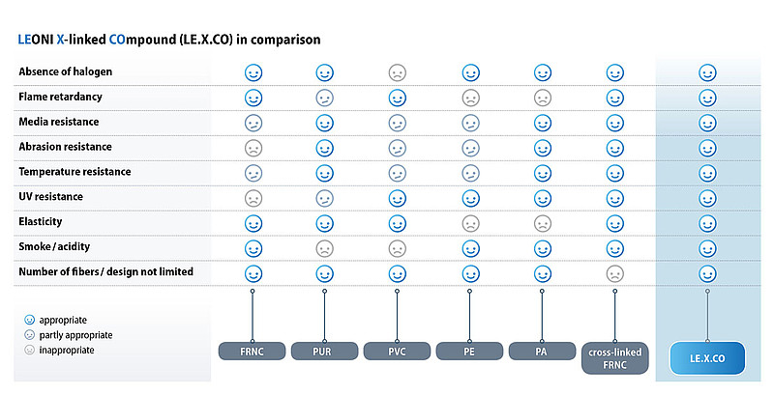

(2,780 characters incl. blanks)

Related illustration material can be downloaded next to this release at
https://www.leoni.com/en/press/releases/details/leoni-provides-innovative-x-linked-compound-for-all-areas-of-large-scale-projects
About Business Unit Fiber Optics
The Business Unit Fiber Optics of the LEONI group is one of the leading manufacturers of fiber optics for special applications in the industrial sector, in sensory and analysis, science, communication as well as laser surgery. LEONI Fiber Optics offers a unique product portfolio at every stage of the value-added chain: from the fused silica to preforms and drawn fibers up to fiber optic cables and complete fiber optic systems with in-house developed optical components such as optical switches, splitters and couplers. Having sites in Europe, the USA and Asia, production and services are within easy reach of clients and markets.

About the Leoni Group
Leoni is a global supplier of wires, optical fibers, cables and cable systems as well as related services for the automotive sector and further industries. Leoni develops and produces technically sophisticated products from single-core automotive cables through to complete wiring systems. Leoni’s product range also comprises wires and strands, standardised cables, special cables and cable system assemblies for various industrial markets. The group of companies, which is listed on the German MDAX, employs about 72,000 people in 31 countries and generated consolidated sales of EUR 4.1 billion in 2014 according to preliminary figures.

Contact person for trade press Contact person for economic press
Marian Hartkopf Sven Schmidt
Head of Marketing Corporate Public & Media Relations
Business Unit Fiber Optics LEONI AG
Phone +49 30-530058-13 Phone +49 (0)911-2023-467
E-mail fo-marketing@leoni.com E-mail presse@leoni.com

