Leoni’s consolidated sales up 11 percent in the first quarter of 2017

EBIT margin raised to 4.4 percent – forecast for 2017 reaffirmed

Nuremberg, 10 May 2017 – Leoni, the leading European provider of cables and cable systems to the automotive sector and other industries, increased its consolidated sales by nearly 11 percent year on year to EUR 1.21 billion in the first three months of 2017 (previous year: EUR 1.09 billion). The Company generated more than half of this growth from its own resources. Forming the basis for this were the good order situation in both divisions and the unabatedly heavy demand from the global motor vehicle industry. Earnings before interest and taxes (EBIT) rose from EUR 24.4 million in 2016 to the current figure of EUR 52.9 million, thereby boosting the EBIT margin from 2.2 percent to 4.4 percent. Leoni meanwhile benefited from non-recurring income of EUR 5 million, which was the payout from a fidelity insurance policy in connection with the fraud case uncovered in 2016.
The quarterly after-tax earnings of the Leoni Group, which, with a total of 82,010 people on 31 March 2017, employed 6,832 more staff than one year earlier (75,178), rose from EUR 11.6 million to EUR 33.6 million.
WSD with strong e-mobility business
The Wiring Systems Division (WSD) increased its sales by about 12 percent to EUR 731 million in the first quarter of 2017 (previous year: EUR 651 million). It generated strong growth with wiring systems and cable harnesses for vehicles of carmakers based in Asia and other European countries as well as for passenger cars with electric and hybrid drive. The Wiring Systems Division’s quarterly EBIT improved from EUR 5.0 million to EUR 22.9 million among others thanks to the successfully implemented measures to enhance performance as well as restructuring.
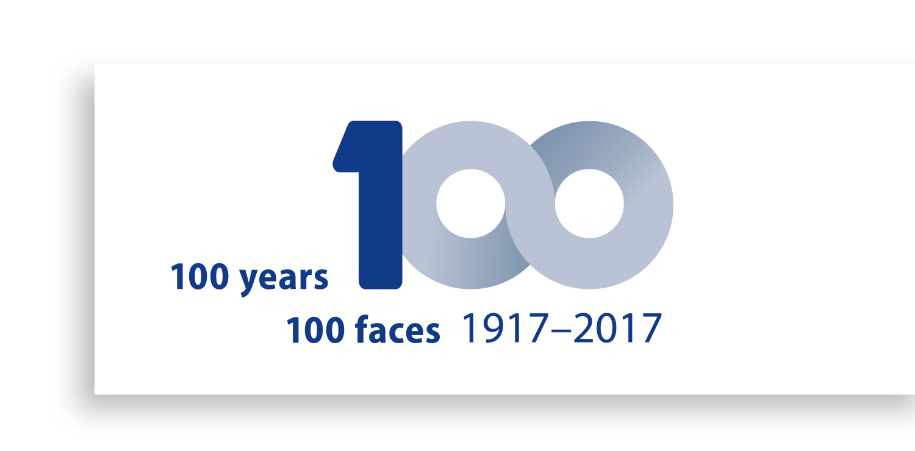During the period under report, the division also booked several new orders in the electromobility segment, in which Leoni meanwhile has an order backlog of about EUR 500 million: among other contracts, German carmakers commissioned Leoni to produce the wiring for two ranges of fully electric premium cars and SUVs.
WCS: strategic realignment stepped up
The Wire & Cable Solutions Division (WCS) increased its sales by about 8 percent to EUR 475 million in the first three months of 2017 (previous year: EUR 438 million), this growth being due to the significantly increased price of copper. The WCS Division's earnings before interest and taxes were up from EUR 19.3 million to EUR 25.0 million in the period under report. Along with the restructuring measures applied in the previous year and the growth with more profitable product and system solutions, positive effects resulting from change in the price of copper also contributed in this respect.
The WCS Division made further progress with its realignment towards becoming a provider of intelligent and secure energy transmission and data management system solutions: By acquiring a majority holding in Adaptricity AG, the division secured access to skills in the fields of software, simulation and cloud-based data analysis. As part of its portfolio streamlining, the Company also completed the sale of its business comprising cable assembly as well as cable harnesses for domestic appliances and power tools.
Full-year forecast reaffirmed
Following its good start into fiscal 2017, Leoni reaffirms its full-year forecast: Group-wide, sales are projected to increase by approximately 4.5 percent to about EUR 4.6 billion, while earnings before interest and taxes are projected to improve to between EUR 180 and 200 million (previous year: EUR 78.1 million).
(3,639 characters incl. blancs)
Related illustration material can be downloaded next to this release at www.leoni.com/en/press/releases/details/leonis-consolidated-sales-up-11-percent-in-the-first-quarter-of-2017/
The complete quarterly report can be found at www.leoni.com/en/financial-publications
Leoni performance overview
Group key figures | Q1 2017 | Q1 2016 | Change
Sales [€ million] | 1,205.5 | 1,089.3 | 10.7 %
EBITDA [€ million] | 90.0 | 61.3 | 46.8 %
EBIT [€ million] | 52.9 | 24.4 | >100 %
Adjusted EBIT ⁽¹⁾ [€ million] | 51.7 | 30.3 | 70.6 %
EBT [€ million] | 47.7 | 18.9 | >100 %
Consolidated net income [€ million] | 33.6 | 11.6 | >100 %
Capex ⁽²⁾ [€ million] | 50.0 | 38.8 | 28.9 %
Equity ratio [%] | 30.8 % | 34.1 % | --
Earnings per share [€] | 1.02 | 0.35 | >100 %
Employees [as at 31 March] | 82,010 | 75,178 | 9.1 %

- Earnings adjusted for the impact of purchase price allocation, restructuring, impairment of non-current assets, gains on business disposals and on business combinations including related derivatives and insurance compensation.
- Including acquisitions
About the Leoni Group
Leoni is a global supplier of wires, optical fibers, cables and cable systems as well as related services for the automotive sector and further industries. Leoni develops and produces technically sophisticated products from single-core automotive cables through to complete wiring systems. Leoni’s product range also comprises wires and strands, standardised cables, special cables and cable system assemblies for various industrial markets. The group of companies, which is listed on the German MDAX, employs about 80,000 people in 31 countries and generated consolidated sales of EUR 4.4 billion in 2016.

Contact person for journalists
Sven Schmidt
Corporate Public & Media Relations
LEONI AG
Phone +49 (0)911-2023-467
Fax +49 (0)911-2023-231
E-mail presse@leoni.com

